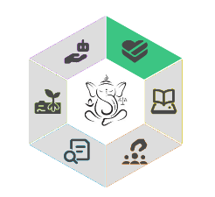
AI GANESH rubric
Goodwill
Goodwill represents the intention to promote well-being and beneficence through AIED, while minimizing harms and negative consequences
Code | Level 1: Sufficient | Level 2: Insufficient | NA | Comments
Student-Centered Decision-Making (EN-G1)
AIED Adaptation & Educator support (EN-G2)
Strategic AI Promotion (EN-G3)
Ethical System Design & Use (EN-G4)
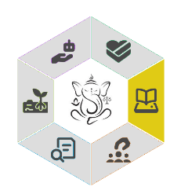
Aptness for Education
Aptness for Education represents the alignment of AIED tools with educational values, learning goals and learner competences.
Code | Level 1: Sufficient | Level 2: Insufficient | NA | Comments
Goal Alignment & Evidence (EN-A1)
Support for Diverse Skills (EN-A2)
Reflective Use by Educators (EN-A3)
Instructional Alignment (EN-A4)
Skill Scaffolding (EN-A5)
Transparent Learning Goals (EN-A6)
Tool Evaluation (EN-A7)
Student AI Literacy (EN-A8)
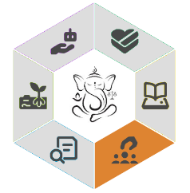

Non-discrimination
Non-discrimination represents fairness, equity and equality in AIED applications.
Code | Level 1: Sufficient | Level 2: Insufficient | NA | Comments
Diversity & Interdisciplinary Teams (EN-N1)
Education-to-Industry Support (EN-N2)
Bias Monitoring & Ethics (EN-N3)
Equity & Inclusion (EN-N4)
Fairness & Access (EN-N5)
Stakeholder Involvement (EN-N6)

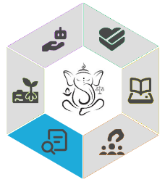
Explicability
Explicability represents the ability to explain an algorithm's workings, outputs and decisions in human terms, and to justify these when needed
Code | Level 1: Sufficient | Level 2: Insufficient | NA | Comments
Stakeholder Responsibilities & Governance (EN-E1)
AI in Educational Practice (EN-E2)
Developer Awareness of Impact (EN-E3)

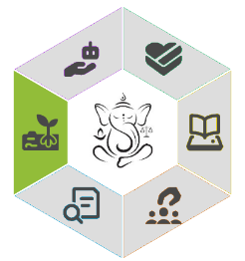
Stewardship of Data
Stewardship of Data represents various concepts related to data – ranging from accuracy to privacy to security to data transparency
Code | Level 1: Sufficient | Level 2: Insufficient | NA | Comments
Data Integrity & Context (EN-S1)
Policy Influence (EN-S2)
Education on AI Risks & Bias (EN-S3)
Ethical Data Use (EN-S4)
Privacy & Data Usage (EN-S5)
Privacy-by-design integration (EN-S6)
Innovation & Testing Environment (EN-S7)
Correctness of results (EN-S8)
Legal Compliance & Oversight(EN-S9)
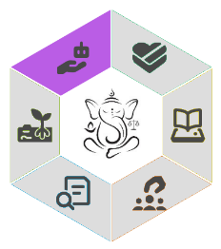

Human oversight
Human oversight represents the necessity of human agency, responsibility and human intervention in AIED tools.
Code | Level 1: Sufficient | Level 2: Insufficient | NA | Comments
Decision Verification (EN-H1)
Human Connection (EN-H2)
Clear Role Allocation (EN-H3)
Professional Development (EN-H4)
Learner Control (EN-H5)
AI Awareness & Impact Knowledge (EN-H6)
Student Accountability (EN-H7)
Non-AI Alternatives (EN-H8)
Informed Consent (EN-H9)

